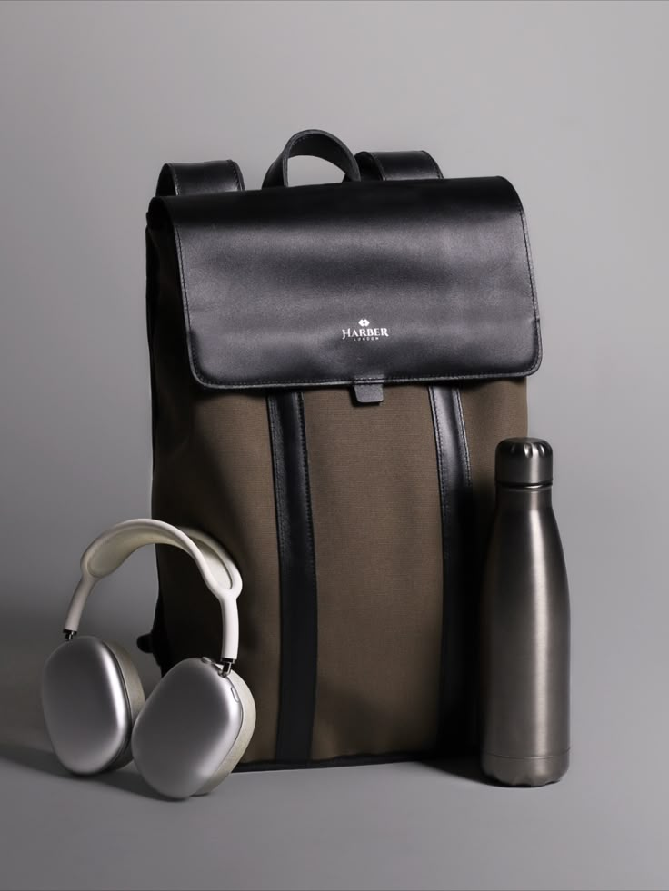Product Details

Product name : Commuter Backpack.

**[**Commuter Backpack **image]**

**Brand : NEXTAG**

**Model : Sbs-5101-BLK**

**Price: PKR 2,000**

**Description:**

Unmatched Quality Designed with functionality in mind, features a spacious interior to keep your belongings organized and easily accessible

**Grain Leather**  
**Material (Grain Type):** High-quality **Full-Grain Leather** with waterproof fabric

**Maintenance:** Requires regular conditioning to keep the leather soft and prevent drying.

**Usage Guidelines**

**Daily Use:** Suitable for commuting, travel, and everyday essentials. Avoid overloading beyond the recommended capacity to prevent strain on stitching and zippers.

**Laptop Compatibility:** Designed to safely store laptops and tablets. Always use a protective sleeve if carrying sharp or heavy objects inside.

**Weather Resistance:** The backpack is made with water-resistant materials but is not fully waterproof. Avoid prolonged exposure to rain

**Warranty Coverage**

This warranty applies to defects in materials and craftsmanship, including:

Faulty stitching or loose seams

Hardware issues (broken zippers, buckles, or clasps)

Defects in leather or fabric (not due to natural aging)

**Exclusions**

This warranty does not cover:

Normal wear and tear, scratches, stains, or discoloration

Damage caused by improper use, accidents, or modifications

Exposure to extreme conditions (water, heat, chemicals)

**How to Claim Warranty**

To request a warranty claim, please provide:

1. Proof of purchase (receipt or order confirmation)
2. Photos of the defect
3. A brief description of the issue